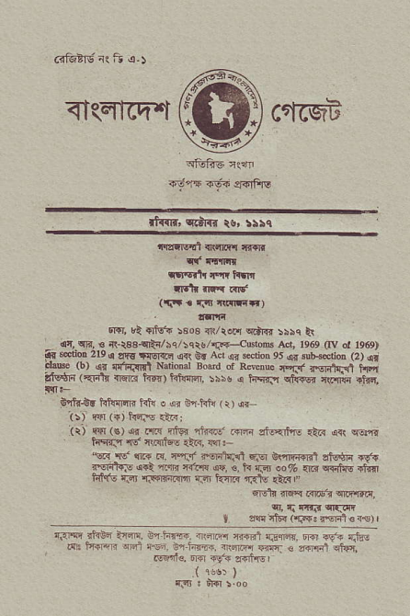
<IsErrcq.t ^{c6rrqF} ffi
_{f?fifi,} ^{qa:ral} ts, r5tq
'llrrlqit ^{{slEq n.n '} if c'rl[Ir
lr|!6ih r.{r lrft
qi.t '. niC
i{F . -rr rmtir)
6FI, ut €tr{ :sos ^{lll/i.ar !dR! :5sc} *
{i, crn, i ^{a.iae{ti/hq,} 5qrt. rF---(\do@ Acr. 1969 rfv _{o!} j95g) _{ar} ^{6crioD 2lo} I _{rrE rllf{q} ^{jrr} C. Air q ^{srio! 9s} _{o!} lu!{eiid ^{(2) {,} _{orie} ^{(b)} rr rrliilnt Nrrmar ^{soard or Rf@& q,fs} r.sBlq{ h,,f _{iii6*F} ^{(qFlr} .-@ i{6\'il@a ri\s r _{FF3n} ^{qtti@} 'l!a; +ftq.
tr{$r hiiEnn t{tr e {r &-tstu ⁽ r) ar
ijt ffi ({) n6Js <tij
(r) a+I (€) ^{q{} .'li{ r)tF {i!.d .+@ aMnE _{{tr} qrt qsntr _{tdqr.9r} qg. ^{'R.{tuE} .tr., {q:-
^{,€F} ₁₆ ^{qrF} .s, n !5 tuT'i€l *r €\'ll{'lil s&]i .t'{ _{Ni:q$} ^{q{t} _{"a-'} 'ffi ,s. €. t r.m ro% _{{n} ^{qntis} .*fl hlt's r.'|J nrsFir{m{ {3r F-4ir ^{'rde} €.{r
^{qrdr} _{ffi mF.i} qrE{id,
iit, q c{ra o<ar
_{alq! rlF r'rF: rEFl c} ^{qs,} I
i{1rffi. {'6rd a.ild {.6$a{,
fitn, Gn hrdr, rnffi +"fi: €
rrqnl€. 6R Ffi a{ltEl
{rs)

